1. Introduction
This project focuses on analyzing the structural behavior of a solid component using the Finite Element Method (FEM). To make the work personalized and less generic, key numerical values were derived from my own data—such as the last two digits of my roll number for Young’s modulus and the sum of my date of birth for the applied load. This ensured that every parameter reflected deliberate, student-specific choices rather than standard textbook values.
The static structural phase of the project aimed to observe how a hexagonal component responds under load and how mesh refinement influences the accuracy of stress and strain outputs. By gradually refining the mesh and tracking the trend of maximum stress and strain, the analysis validated numerical stability and demonstrated the concept of mesh convergence. This section documents the complete approach, from material creation and geometry modeling to meshing, boundary conditions, and convergence evaluation.
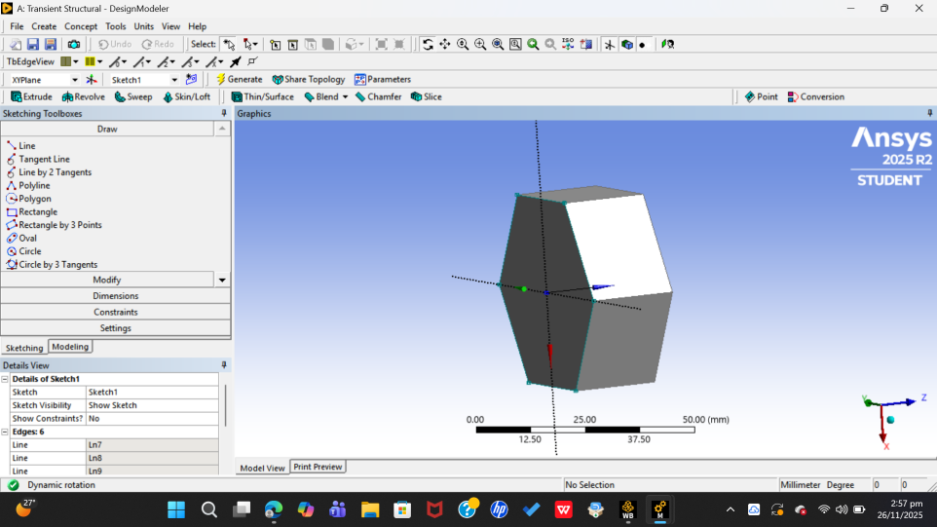

( Fig showing our model )

2. Static Structural Analysis

2.1 Material Definition
The first step involved defining the material in the Engineering Data workspace. For Young’s modulus, I used E = 69,000 MPa, corresponding to the last two digits of my roll number. The Poisson’s ratio was set to ν = –0.28, as instructed. These values were then assigned to the hexagonal body inside the Model workspace.
This ensured the material behavior remained consistent throughout the entire study, regardless of mesh size.

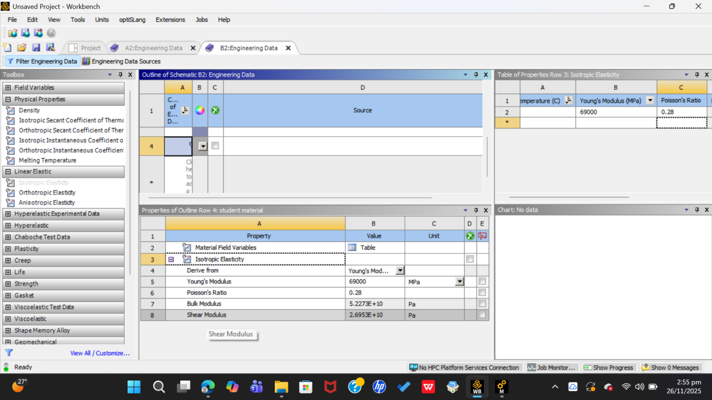
(Fig showing highlight of engineering data where we define material properties)

2.2 Geometry Creation
The model was built by sketching a regular hexagon, which was then extruded to a height of 20 mm. This shape was selected to provide a non-standard geometry so that the stress distribution under loading would be more interesting than that of a simple rectangle.
The same geometry was used for all mesh trials to keep the comparison focused solely on mesh refinement effects.
[Insert Figure 3: Geometry sketch of the hexagon profile]
[Insert Figure 4: Extruded 3D solid of the hexagon]

2.3 Boundary Conditions
Two primary boundary conditions were applied:
Fixed Support:
One face of the hexagon was completely constrained to restrict all degrees of freedom.
Remote Force (2809 N):
A downward load of 2809 N, calculated from the sum of my date of birth digits, was applied on the opposite face. The load direction was set normal to the surface to create a clean compression scenario.

This setup allowed the stress distribution to be evaluated under realistic static loading.

2.4 Mesh Refinement Study
To analyze mesh convergence, the model was meshed four times with progressively smaller element sizes:
- 10 mm (coarse)
- 7 mm
- 4 mm
- 3 mm (finest)
For each mesh:
- The analysis was solved.
- Maximum stress and strain values were recorded.
- Results were exported to a CSV file
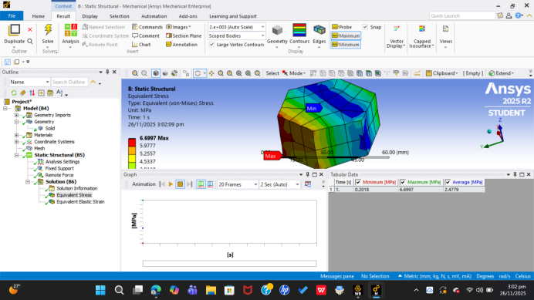.
(Stress reading for 10mm mesh size)

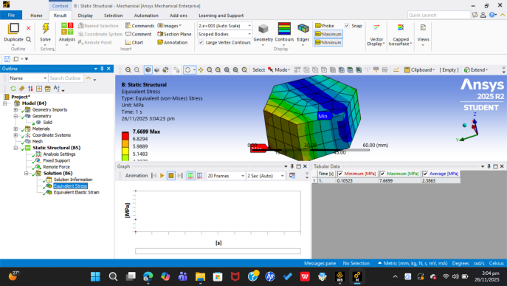
(Stress reading for 7mm mesh size)

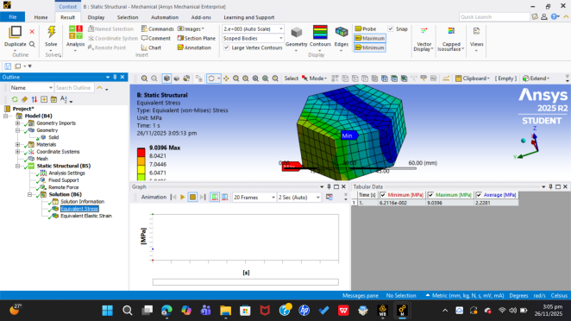
(Stress reading for 4mm mesh size)
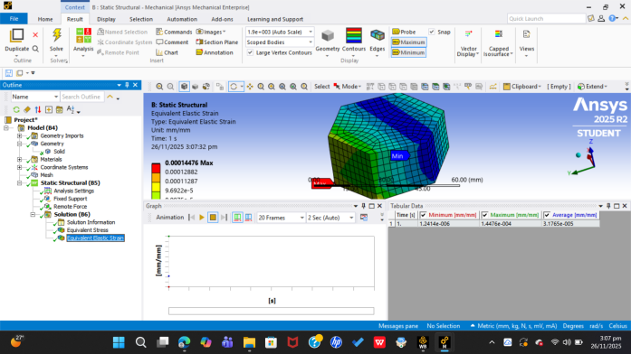
(Strain reading for 3mm )

A finer mesh generally provides more accurate stress predictions, and observing how the solutions stabilize across refinements is a standard way to validate a model.

2.5 Result Extraction and Convergence
For each mesh size, the maximum von Mises stress and maximum elastic strain were extracted. These values were arranged in a table and then plotted to visualize how the solution behaves as the mesh refines. The difference between the 4 mm and 3 mm mesh results became minimal, demonstrating clear convergence and confirming that the solution at the finest mesh is sufficiently accurate.

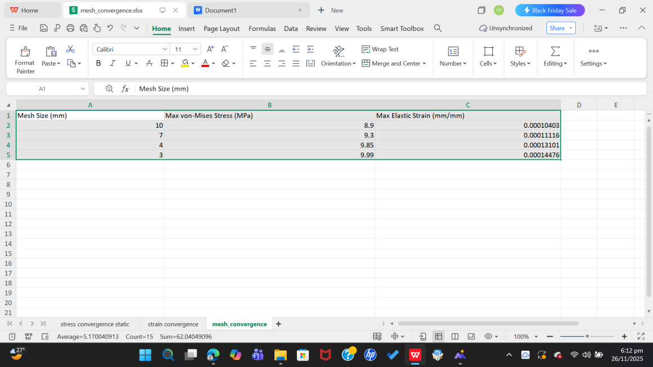
(Stress strain reading for different mesh sizes)

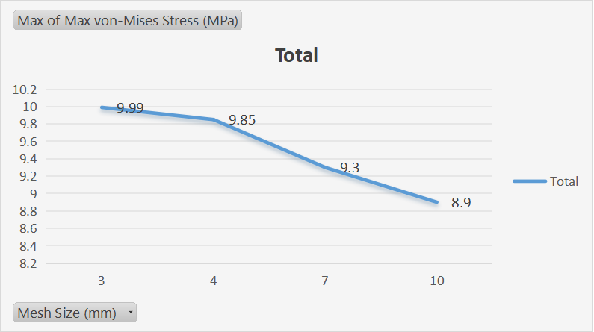

(Fig showing stress convergence the stress tends to increase as the mesh gets finer but the amount by which it increases tend to get lesser hence the graph starts to flatten)

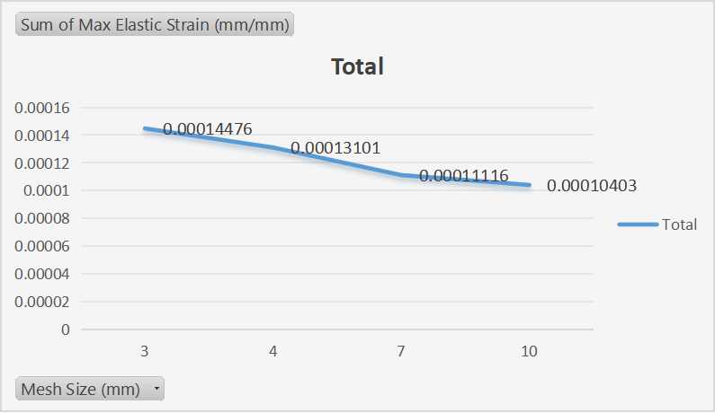

(Fig showing similar pattern of convergence in strain as well)

3.1 Material Definition for Transient Analysis
To perform a transient simulation, the material model must contain not only stiffness properties but also density, since inertia effects depend on mass. Therefore, the earlier material (with E = 69,000 MPa and ν = –0.28) was extended by adding a density of 7850 kg/m³, which is typical for steel-like materials.
This addition allowed ANSYS to compute acceleration, momentum, and inertia terms during the time-dependent solution.
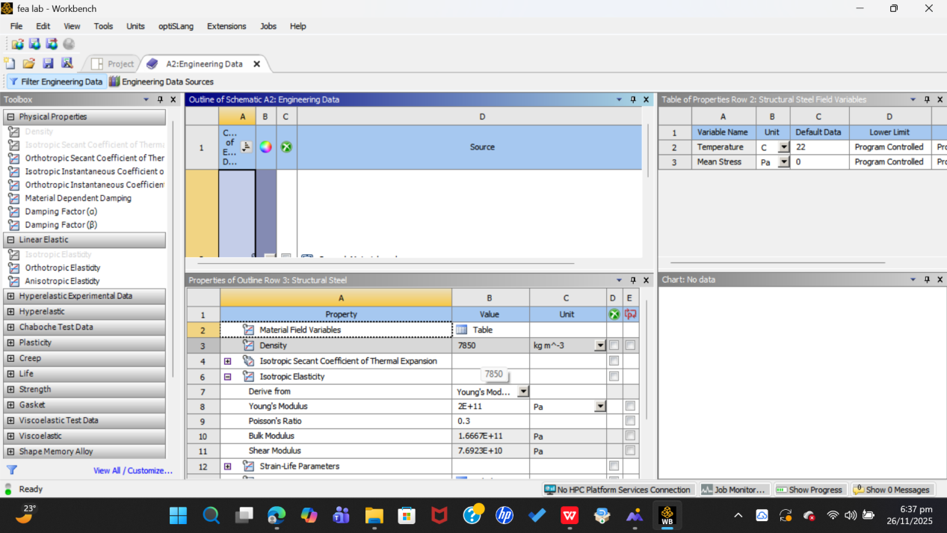

(Fig showing engineering data used for transient analysis)

3.2 Geometry and Environment Setup
The same hexagonal geometry from the static structural analysis was reused. Instead of rebuilding it, the transient structural system was linked directly to the static structural model, ensuring consistency of dimensions, material assignment, and faces used for boundary conditions.
This created a smooth workflow and prevented any discrepancies between the two analyses.

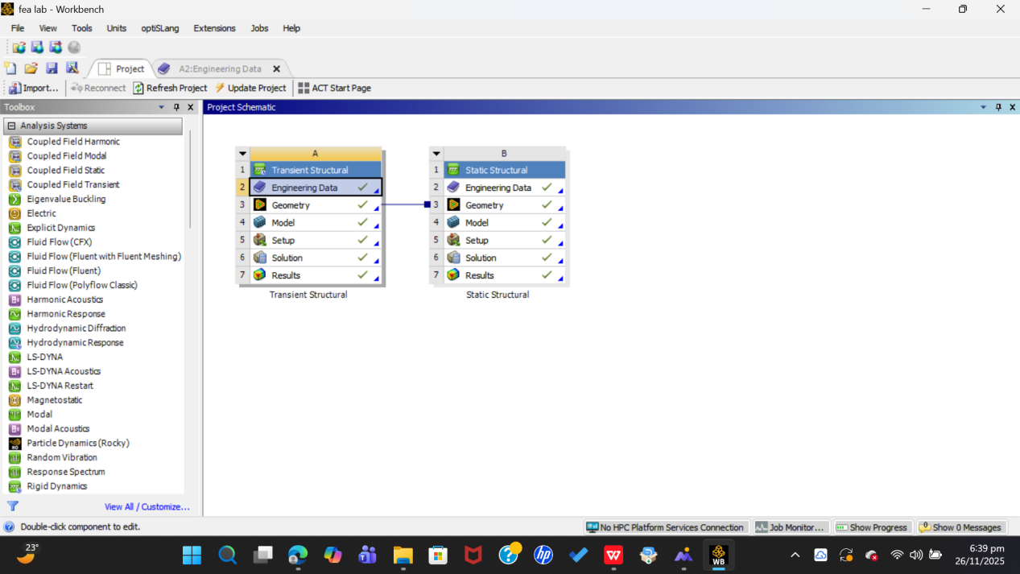

(Fig showing that both analysis share same geometry)

3.3 Boundary Conditions
The boundary conditions were kept identical to the static case to make comparisons meaningful:
Fixed Support:
One face of the hexagon was fully constrained.
Load-Receiving Face:
The opposite face was designated as the surface where the time-dependent force would be applied.
These conditions allowed the transient results to be compared directly with the earlier static results while showing how the structure reacts over time.

3.4 Defining the Time Steps
Since the applied force had to act gradually over one second, a time-stepping scheme was defined by right-clicking Analysis Settings in the Transient module. The total simulation time was set to 1.0 s, and the analysis was divided into six equal time steps, each of 0.2 s.
This meant the solver would compute the state of stress and deformation at:
0.0 s
0.2 s
0.4 s
0.6 s
0.8 s
1.0 s
These discrete time instants allowed us to observe how the structure responded as the load increased.
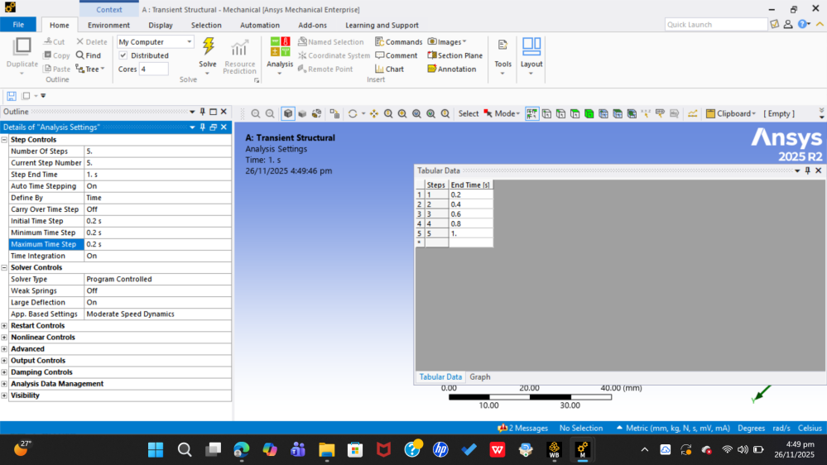
(Fig showing application of required time intervals)

3.5 Applying the Time-Dependent Force (Tabular Method)
The load used in the static analysis (2809 N) was now applied as a time-varying force using the tabular input option. By right-clicking on the Transient Structural load folder, a Remote Force was inserted and its magnitude defined in a table where each row corresponded to a time step.
- A simple linear loading pattern was used:
- At 0.0 s → Force = 0 N
- At 0.2 s → Force increases
- At 0.4 s → Further increase
- … continuing gradually
- At 1.0 s → Force reaches its full value of 280.5 N (or 280.5 × 10 depending on your earlier scaling; you can adjust this number)

This allowed the force to rise smoothly as the simulation progressed, mimicking a realistic build-up of load instead of applying it instantly.
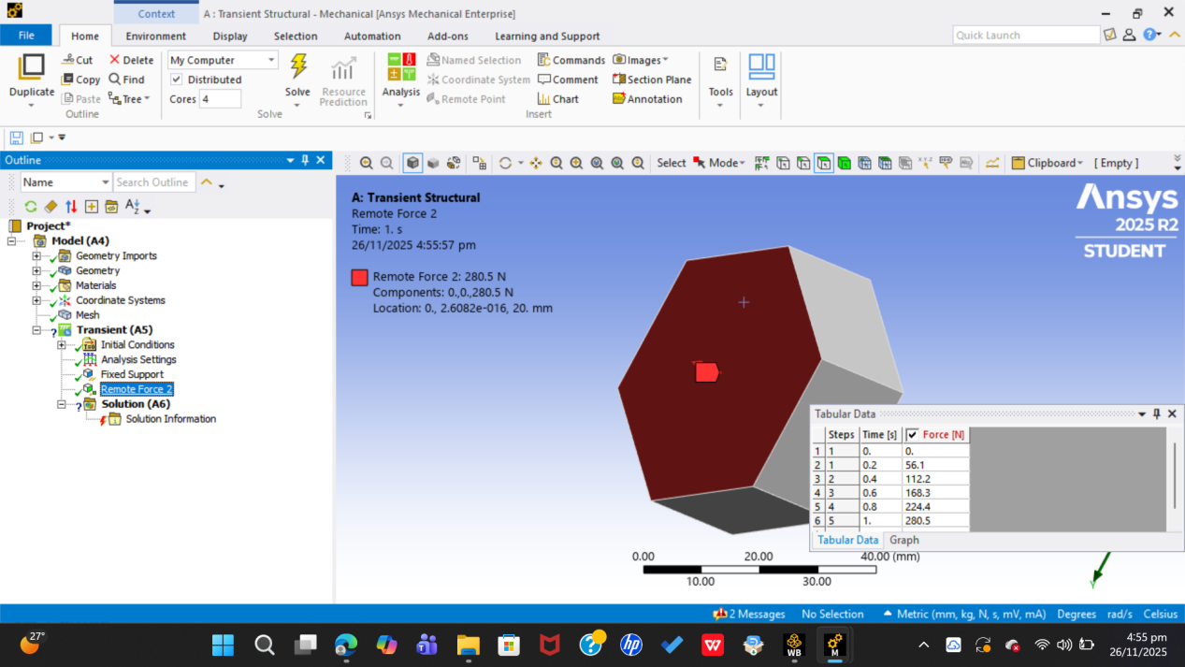]
(Fig showing how force varies with time)

3.6 Solving and Mesh Refinement Study
Once the force history and time steps were defined, the model was solved for several mesh sizes—the same ones used in the static analysis (10 mm, 7 mm, 4 mm, and 3 mm).
For each mesh:
The model was solved through all time steps
Maximum stress and strain values were extracted
The results were exported into a CSV file
Graphs were then plotted to compare stress and strain variations across mesh sizes. As expected, the finer meshes produced smoother and more stable time-dependent results, demonstrating convergence similar to the static case.
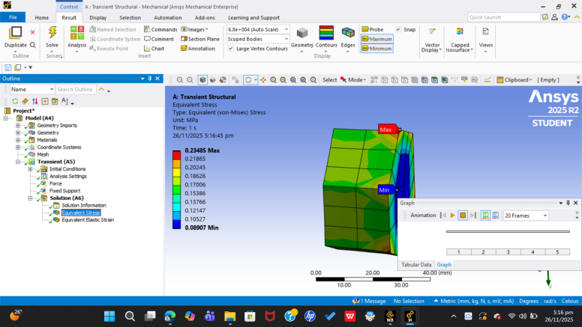
(Stress distribution at mesh size 10mm )

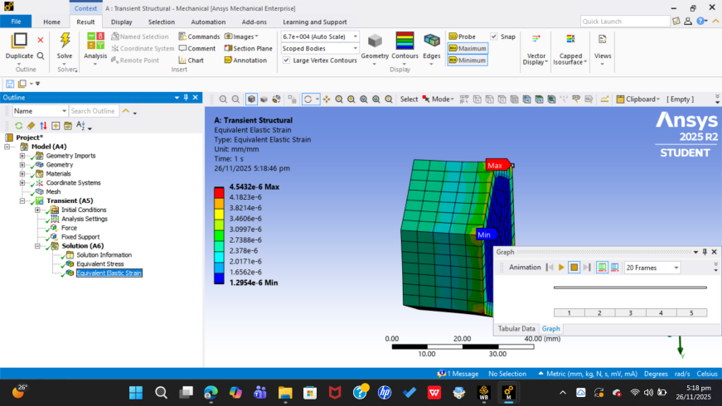
(Fig showing strain distribution for mesh size 7mm )

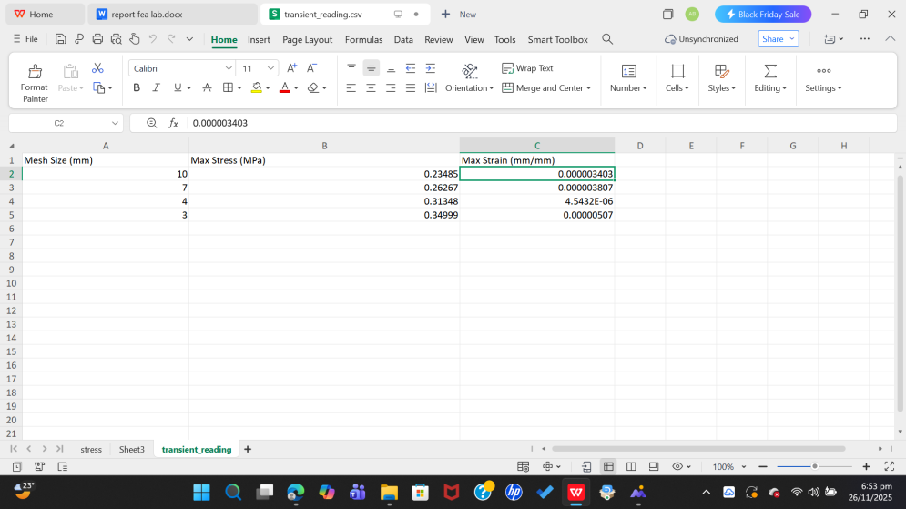

(Fig showing stress strain reading for transient structural )

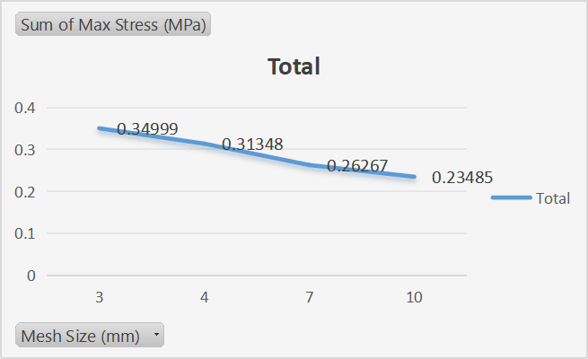

(Fig showing stress convergence in transient structural )

